

INTERIOR ALTERATIONS
UNION COUNTY EDUCATIONAL
SERVICES COMMISSION
WESTLAKE SCHOOL / UCESC BOE53 CARDINAL DR.,
WESTFIELD, NEW JERSEY 07090
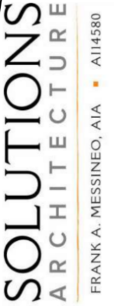
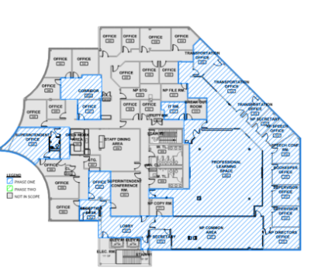
ARCHITECH PROJECT NUMBER
25.138B

SOLUTIONS ARCHITECH
96 Pompton Avenue Verona NJ 07044

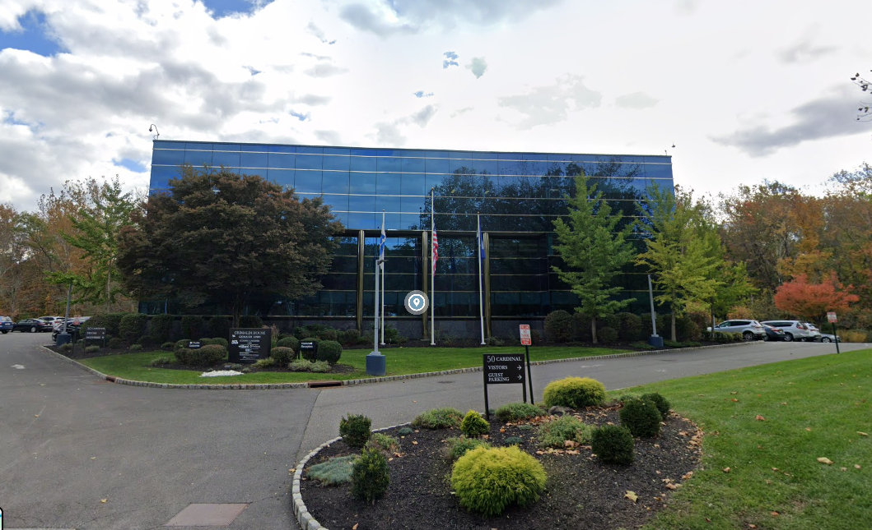

SUMMARY:
The project consists of reconstructing of the first and second floors to create classrooms and program areas necessary for school operations, including complete interior demolition, new partition walls, new plumbing, and new finishes, along with partial alterations to the third floor to provide a large assembly space and expanded office areas; this work will also result in a change of use and occupant load, with the first and second floors being reclassified from use group “B” to use group “E,” while third floor will remain as use group “B.”

Project: Interior Alterations – Union County Educational Services Commission (Westlake School / UCESC BOE)
Location: 53 Cardinal Drive, Westfield, NJ 07090.
Building Type
- Existing Building Use: Group B (Business).
- New Building Use:
  - 1st & 2nd Floors → Group E (Educational)
  - 3rd Floor → Group B (Business) remains.
- Construction Type: Type IIB.
- Building Size: Approx. 46,911 SF.
- Stories: 3 Stories.
Scope of Work
- Major interior renovation.
- New classrooms and educational spaces.
- New offices, nurse area, faculty areas.
- New toilet renovations.
- New storefronts/secure vestibule.
- New doors, frames, hardware, finishes, ceilings, MEP upgrades.
General Observations
- Fully sprinklered building.
- Secure vestibule and access-control system.
- Multiple fire-rated corridor doors.
- Card readers at selected openings.
- Hollow metal frames used extensively throughout project.
- Majority of openings are wood doors in HM frames.

DOOR SCHEDULE SUMMARY
Door Quantity
- Door schedule contains 152 door openings across all floors.

ALUMINUM DOORS & STOREFRONT DOOR TO EXCLUDE
The following schedule doors are Aluminium (AL) and storefront door should be excluded from HM/Wood door take-offs:
- Total AL & Storefront Doors to Exclude = 9 Doors.
- The Door No. 100H.1 is storefront opening although door frame is hollow metal
- The Door No. 100C,101D,113A,200D,223 is storefront opening although door is SWC frame is hollow metal

WINDOWS SUMMARY
- In the window schedule, the quantity for Window Type W2 is listed as 2; however, the actual quantity is 3.
- The W1-type window has been excluded because it is AL.

HOLLOW METAL DOOR / FRAME SPECIFICATION SUMMARY
Specification Section
08 12 13 – Hollow Metal Frames.

Approved Manufacturers
Hollow Metal Manufacturers
- Curries
- Steelcraft
- Ceco Door Products

Hollow Metal Material
- Galvannealed Steel
- Cold-Rolled Steel
- Hot-Rolled Steel

Door / Frame Gauge
Hollow Metal Frames
- 16 Gauge Steel
- Thickness: 0.053"

Door Thickness
- 1-3/4" Thick

Fire Ratings
Many openings are:
- 60 Minute Fire Rated
- UL Listed
- NFPA 80 Compliant
- NFPA 252 Compliant

Key Finding
The project is primarily an Educational Facility (Group E) renovation with 152 doors, where most openings consist of solid core wood doors in hollow metal frames, and only 3 aluminum storefront doors are identified for exclusion from the hollow metal/wood door package.

